SQL:

SQL (Structured Query Language) is used to perform operations on the records stored in the database, such as updating records, inserting records, deleting records, creating and modifying database tables, views, etc.

SQL is not a database system, but it is a query language.

Suppose you want to perform the queries of SQL language on the stored data in the database. You are required to install any database management system in your systems, for example, Oracle

, MySQL

, MongoDB

, PostgreSQL

, SQL Server

, DB2

, etc.

Why SQL?

Nowadays, SQL is widely used in data science and analytics. Following are the reasons which explain why it is widely used:

* The basic use of SQL for data professionals and SQL users is to insert, update, and delete the data from the relational database.
* SQL allows the data professionals and users to retrieve the data from the relational database management systems.
* It also helps them to describe the structured data.
* It allows SQL users to create, drop, and manipulate the database and its tables.
* It also helps in creating the view, stored procedure, and functions in the relational database.
* It allows you to define the data and modify that stored data in the relational database.
* It also allows SQL users to set the permissions or constraints on table columns, views, and stored procedures.

-----------------------------------------------------

Structured Query Language is a standard Database language which is used to create, maintain and retrieve the relational database. Following are some interesting facts about SQL.

* SQL is case insensitive. But it is a recommended practice to use keywords (like SELECT, UPDATE, CREATE, etc) in capital letters and use user defined things (liked table name, column name, etc) in small letters.
* We can write comments in SQL using “–” (double hyphen) at the beginning of any line.
* SQL is the programming language for relational databases (explained below) like MySQL, Oracle, Sybase, SQL Server, Postgre, etc. Other non-relational databases (also called NoSQL) databases like MongoDB, DynamoDB, etc do not use SQL

.

**What is Relational Database?**

Relational database means the data is stored as well as retrieved in the form of relations (tables). Table 1 shows the relational database with only one relation called **STUDENT** which stores **ROLL_NO**, **NAME**, **ADDRESS**, **PHONE** and **AGE** of students.

**STUDENT**

|  |  |  |  |  |
| --- | --- | --- | --- | --- |
| **ROLL_NO** | **NAME** | **ADDRESS** | **PHONE** | **AGE** |
| 1 | RAM | DELHI | 9455123451 | 18 |
| 2 | RAMESH | GURGAON | 9652431543 | 18 |
| 3 | SUJIT | ROHTAK | 9156253131 | 20 |
| 4 | SURESH | DELHI | 9156768971 | 18 |

**Attribute:** Attributes are the properties that define a relation. e.g.; **ROLL_NO**, **NAME** etc.

**Tuple:** Each row in the relation is known as tuple. The above relation contains 4 tuples, one of which is shown as:

|  |  |  |  |  |
| --- | --- | --- | --- | --- |
| 1 | RAM | DELHI | 9455123451 | 18 |

. **Binary Datatypes :**  
There are four subtypes of this datatype which are given below :

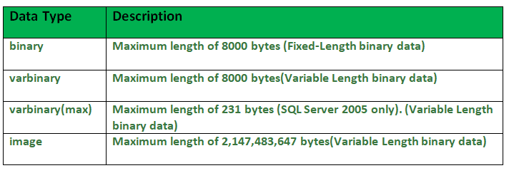

2. **Exact Numeric Datatype :**  
There are nine subtypes which are given below in the table. The table contains the range of data in a particular type.

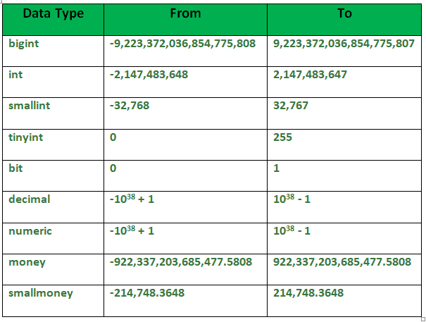

**3. Approximate Numeric Datatype :**  
The subtypes of this datatype are given in the table with the range.

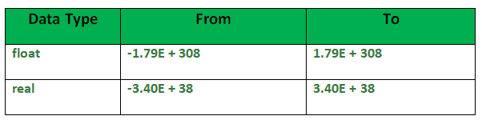

**4. Character String Datatype :**  
The subtypes are given in below table –

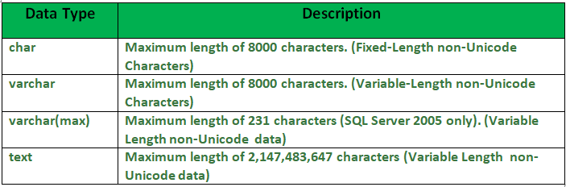

**5. Unicode Character String Datatype :**  
The details are given in below table –  
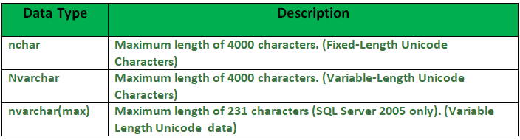

**6. Date and Time Datatype :**  
The details are given in below table.  
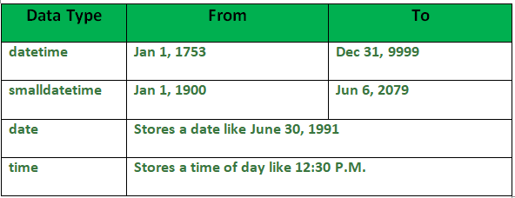

1. What is the maximum value that can be stored in NUMERIC(4,2)?

A. 9999.99  
B. 99.9999  
C. 99.99  
D. 9.99

View Answer

Ans : C

Explanation: 99.99 is the maximum value that can be stored in NUMERIC(4,2)

2. Determine data type for the given column? Column Name: Price ; Description: Cost of an item in rupees and paise ; Example: 200.21

A. VARCHAR2(50)  
B. NUMBER  
C. NUMBER(5,2)  
D. NUMBER(6)

View Answer

Ans : C

Explanation: NUMBER(5,2) is the data type for the given column.

3. Determine data type for the given column? Column Name: IFSC_Code ; Description: A 11 Character alphanumeric code that identifies a bank branch ; Example: SBIN0009044

A. VARCHAR2(50)  
B. NUMBER  
C. Char(11)  
D. NUMBER(11)

View Answer

Ans : C

Explanation: Char(11) is the data type for the given column.

4. Determine the most suitable data type for the given column? Column Name: Profile_Image ; Description: Image of the employee

A. Clob  
B. Blob  
C. Varchar(100)  
D. None of the above

View Answer

Ans : B

Explanation: Blob is the data type for the given column.

5. The user defined data type can be created using

A. Create datatype  
B. Create data  
C. Create definetype  
D. Create type

View Answer

Ans : D

Explanation: The create type clause can be used to define new types.Syntax : create type Dollars as numeric(12,2) final; .

6. In contemporary databases, the top level of the hierarchy consists of ______ each of which can contain _____

A. Catalogs, schemas  
B. Schemas, catalogs  
C. Alter typeEnvironment, schemas  
D. Schemas, Environment

View Answer

Ans : A

Explanation: In contemporary databases, the top level of the hierarchy consists of Catalogs each of which can contain schemas.

7. Choose the most suitable data type in case multiple data types are possible for the column. Column Name: PIN_Code ; Description: Six digit numeric PIN code for any address in India ; Example: 560100

A. Integer  
B. VARCHAR2(11)  
C. CHAR(11)  
D. Number(6)

View Answer

Ans : D

Explanation: Number(6) is the most suitable data type in case multiple data types are possible for the column

8. Choose the most suitable data type in case multiple data types are possible for the column. Column Name: Student_id ; Description: Unique number assigned to every Student ; Example: 100000

A. Integer  
B. VARCHAR2(11)  
C. CHAR(11)  
D. Number(6)

View Answer

Ans : A

Explanation: Integer is the most suitable data type in case multiple data types are possible for the column

9. Choose the most suitable data type in case multiple data types are possible for the column.Column Name: Date_Of_Birth ; Description: Date of Birth of the employee ; Example: 1990/01/01

A. Timestamp  
B. VARCHAR2(11)  
C. Blob  
D. Date

View Answer

Ans : D

Explanation: Date is the most suitable data type in case multiple data types are possible for the column

10.  SQL allows comparison operations on the data types i.e.

A. Date  
B. Timestamp  
C. Time  
D. All of the above

View Answer

Ans : D

Explanation: SQL allows comparison operations on the all of the above data types .

DDL:

•  [CREATE](https://www.w3schools.in/mysql/php-mysql-create/) - to create a database and its objects like (table, index, views, store procedure, function, and triggers)

• ALTER - alters the structure of the existing database

• DROP - delete objects from the database

• TRUNCATE - remove all records from a table, including all spaces allocated for the records are removed

• COMMENT - add comments to the data dictionary

• RENAME - rename an object

|  |  |
| --- | --- |
| CREATE | Used for creating database objects like a database and a database table. |
| ALTER | Used for modifying and renaming elements of an existing database table. |
| DROP | Used for removing an entire database or a database table. |
| TRUNCATE | Used to remove all the records from a database table. |
| COMMENT | Used to write comments within SQL queries. |

CREATE DATABASE DatabaseName;  
CREATE TABLE TableName (Column1 Datatype1, Column2 Datatype2,…,ColumnNDatatypeN);

For example, we will create a table named ‘Emp’ with some fields and similar data types that are valid in MySQL and respectively a database named ‘EmpDB’ in MySQL server using the queries below:

Example:

CREATE DATABASE EmpDB;

CREATE TABLE empdb.Emp (Emp_ID INT PRIMARY KEY AUTO_INCREMENT, Emp_Name VARCHAR(255), Emp_City VARCHAR(255), Emp_AdmDate DATE NOT NULL);

Assignment:

Crate table with student and columns id,name,age,address

Alter:

Syntax:

ALTER TABLE TableName ADD ColumnNameData_Type;  
ALTER TABLE TableName DROPColumnName;  
ALTER TABLE TableName MODIFY COLUMNColumnNameData_Type;

Example:

ALTER TABLE empdb.Emp ADD Emp_Contact INT NOT NULL;

ALTER TABLE empdb.Emp DROP Emp_Contact;

select * from empdb.emp;

ALTER TABLE empdb.Emp MODIFY COLUMN Emp_AdmDate Year;

ALTER TABLE table_name RENAME COLUMN old_column_name TO new_column_name;

Assignment:alter student table

Drop:

Syntax:

**Code:**

DROP TABLE TableName;

Example:

DROP Table Emp;

Assignment :drop student table:

Assignment:create another table and insert records and truncate records using below command

Truncate:

Syntax:

TRUNCATE TABLE TableName;

Example:

TRUNCATE TABLE microdb.users;

#### 5. COMMENT Command

/*selectingall columns from table Employee existing in the database: */

SELECT * FROM microdb.users;

DML Commands:

DML is short name of **Data Manipulation Language** which deals with data manipulation and includes most common SQL statements such SELECT, INSERT, UPDATE, DELETE, etc., and it is used to store, modify, retrieve, delete and update data in a database.

* [SELECT](https://www.w3schools.in/mysql/php-mysql-select/) - retrieve data from a database
* [INSERT](https://www.w3schools.in/mysql/php-mysql-insert/) - insert data into a table
* [UPDATE](https://www.w3schools.in/mysql/php-mysql-update/) - updates existing data within a table
* [DELETE](https://www.w3schools.in/mysql/php-mysql-delete/) - Delete all records from a database table

#### 1. INSERT

It is used to insert or add new rows or records in the existing table.

**Syntax:**

Insert into <table_name> values(<value1>,<value2>,<value3>…….,<valuen>);

Where,

* **table name:** The name of the table In which the data needs to be inserted.
* **values:** values for each column of the table.

create table students (roll_no int,student_name varchar(150),course varchar(150));

insert into students values(1,'ashish','java');

Insert into students values(2,’rahul’,’C++’);

select * from students;

select student_name from students;

select roll_no, student_name, course from students where roll_no=3;

update:

Update<table_name> set <column_name>=value where <condition>;

Below is the query of the update statement:

update students set roll_no=roll_no+10 where student_name='ashish';

update students12 set student_name='aman' where roll_no=2;

select * from students;

4. Delete

Delete statement is used to delete rows of the table based on the specified conditions.

Syntax:

delete from <table_name> where <condition>;

table_name: Name of the table from which the data needs to be deleted.

condition: Condition based on which the data is to be deleted.

**.**

select * from students;

Output:

Output-1.7

delete from students where roll_no=11;

select * from students;

Output:

Output-1.8

delete from students where student_name= 'divya';

Output:

Output-1.9

delete from students12 where course='Arch';

**. DELETE :**   
DELETE is a [DML(Data Manipulation Language)](https://www.geeksforgeeks.org/difference-between-ddl-and-dml-in-dbms/) command and is used when we specify the row(tuple) that we want to remove or delete from the table or relation. The DELETE command can contain a WHERE clause. If the **WHERE** clause is used with the DELETE command then it removes or deletes only those rows(tuple) that satisfy the condition otherwise by default it removes all the tuples(rows) from the table.  Remember that DELETE logs the row deletions.

**Syntax of DELETE command :**

DELETE FROM TableName

WHERE condition;

**2. TRUNCATE :**   
TRUNCATE is a [DDL(Data Definition Language)](https://www.geeksforgeeks.org/difference-between-ddl-and-dml-in-dbms/) command and is used to delete all the rows or tuples from a table. Unlike the DELETE command, the TRUNCATE command does not contain a WHERE clause. In the TRUNCATE command, the transaction log for each deleted data page is not recorded. Unlike the DELETE command, the TRUNCATE command is fast. We cannot roll back the data after using the TRUNCATE command.

**Syntax of TRUNCATE command:-**

TRUNCATE TABLE TableName;

DQL COMMAND:

Select:

**Basic Syntax:**

**SELECT column1,column2 FROM table_name**

**column1 , column2**: names of the fields of the table

**table_name:** from where we want to fetch

This query will return all the rows in the table with fields column1 , column2.

* To fetch the entire table or all the fields in the table:

SELECT * FROM table_name;

* Query to fetch the fields ROLL_NO, NAME, AGE from the table Student:

SELECT ROLL_NO, NAME, AGE FROM Student;

Output:

| **ROLL_NO** | **NAME** | **Age** |
| --- | --- | --- |
| 1 | Ram | 18 |
| 2 | RAMESH | 18 |
| 3 | SUJIT | 20 |
| 4 | SURESH | 18 |

### **DCL (Data Control Language):**

DCL includes commands such as GRANT and REVOKE which mainly deal with the rights, permissions, and other controls of the database system.

List of  DCL commands:

* [**GRANT:**](https://www.geeksforgeeks.org/mysql-grant-revoke-privileges/)This commandgives users access privileges to the database.
* [**REVOKE:**](https://www.geeksforgeeks.org/difference-between-grant-and-revoke/)This command withdraws the user’s access privileges given by using the GRANT command.

Grant:

**Syntax:**

GRANT privileges_names ON object TO user;

**Parameters Used**:

* **privileges_name**: These are the access rights or privileges granted to the user.
* **object:**It is the name of the database object to which permissions are being granted. In the case of granting privileges on a table, this would be the table name.
* **user:**It is the name of the user to whom the privileges would be granted.

**Privileges**:  
The privileges that can be granted to the users are listed below along with description:  
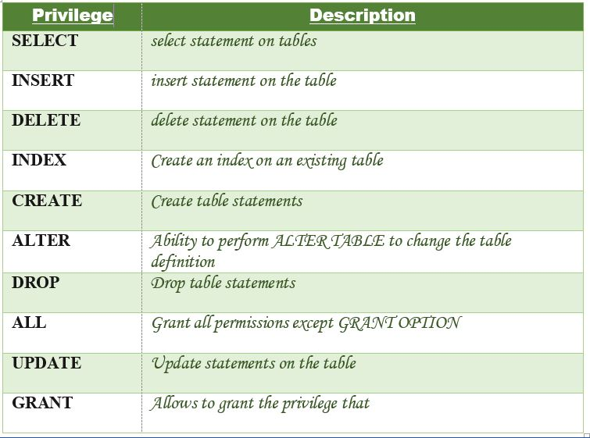

Let us now learn about different ways of granting privileges to the users:

1. **Granting SELECT Privilege to a User in a Table**: To grant Select Privilege to a table named “users” where User Name is Amit, the following GRANT statement should be executed.

GRANT SELECT ON Users TO'Amit'@'localhost;

1. **Granting more than one Privilege to a User in a Table**: To grant multiple Privileges to a user named “Amit” in a table “users”, the following GRANT statement should be executed.

GRANT SELECT, INSERT, DELETE, UPDATE ON Users TO 'Amit'@'localhost;

1. **Granting All the Privilege to a User in a Table**: To Grant all the privileges to a user named “Amit” in a table “users”, the following Grant statement should be executed.

GRANT ALL ON Users TO 'Amit'@'localhost;

1. **Granting a Privilege to all Users in a Table**: To Grant a specific privilege to all the users in a table “users”, the following Grant statement should be executed.

GRANT SELECT ON Users TO '*'@'localhost;

In the above example the “*” symbol is used to grant select permission to all the users of the table “users”.

The Revoke statement is used to revoke some or all of the privileges which have been granted to a user in the past.

**Syntax:**

REVOKE privileges ON object FROM user;

**Parameters Used**:

* **object:**It is the name of the database object from which permissions are being revoked. In the case of revoking privileges from a table, this would be the table name.
* **user:**It is the name of the user from whom the privileges are being revoked.

**Privileges**  
Privileges can be of the following values:  


Different ways of revoking privileges from a user:

1. **Revoking SELECT Privilege to a User in a Table**: To revoke Select Privilege to a table named “users” where User Name is Amit, the following revoke statement should be executed.

REVOKE SELECT ON users TO 'Amit'@localhost';

1. **Revoking more than Privilege to a User in a Table**: To revoke multiple Privileges to a user named “Amit” in a table “users”, the following revoke statement should be executed.

REVOKE SELECT, INSERT, DELETE, UPDATE ON Users TO 'Amit'@'localhost;

1. **Revoking All the Privilege to a User in a Table**: To revoke all the privileges to a user named “Amit” in a table “users”, the following revoke statement should be executed.

REVOKE ALL ON Users TO 'Amit'@'localhost;

1. **Revoking a Privilege to all Users in a Table**: To Revoke a specific privilege to all the users in a table “users”, the following revoke statement should be executed.

REVOKE SELECT ON Users TO '*'@'localhost;